
Banner Finance
Approvals
Training Workbook
Release 8.0 – April 2008
Updated 4/30/2012

_______________________________________________________________________________________________

Ellucian
4 Country View Road
Malvern, Pennsylvania 19355
United States of America
(800) 522 - 4827

Customer Support Center website
http://connect.ellucian.com

Distribution Services e-mail address
distserv@ ellucian.com

Other services
In preparing and providing this publication, Ellucian is not rendering legal, accounting, or other similar professional services. Ellucian makes no claims that an institution's use of this publication or the software for which it is provided will insure compliance with applicable federal or state laws, rules, or regulations. Each organization should seek legal, accounting and other similar professional services from competent providers of the organization's own choosing.

Trademark
Banner®, Colleague®, PowerCAMPUS®, Luminis® and Datatel® are trademarks of Ellucian or its affiliates and are registered in the U.S. and other countries. Ellucian, Advance, Recruiter, and Open Digital Campus are trademarks of Ellucian or its affiliates. Other names may be trademarks of their respective owners.

Revision History Log
Publication Date | Summary
4/31/2008 | New version that supports 8.0 software.
3/26/2009 | Minor changes and additions to workbook
12/01/2011 | Updated to clarify assignment to queues.
4/30/2012 | Updated with the Ellucian template.

Notice of rights
© 2012 Ellucian. All rights reserved.
Contains confidential and proprietary information of Ellucian and its subsidiaries. Use of these materials is limited to Ellucian licensees, and is subject to the terms and conditions of one or more written license agreements between Ellucian and the licensee in question.

Table of Contents
Introduction 4
Process Introduction 6
Types of Approvals 9
Set Up 10
Initiating the Approvals Process 11
Establishing Document Approval Queues 13
Creating Queue Routing Criteria 20
Self Check 23
Answer Key for Self Check 24
Day-to-Day Operations 26
Process Introduction 27
Creating Requisitions for Approval 28
Running the Approvals Process 31
Determining If Documents are Awaiting Your Approval 33
Disapproving Your Own Document Still in an Approval Queue 36
Approving a Document 38
Working with NSF Checking and Approvals 41
Viewing and Overriding NSF Documents 46
Displaying the Approval History for a Specific Document 50
Summary 53
Self Check 54
Answer Key for Self Check 57
Appendix 61
Forms Job Aid 62
Backup Approvers Set Up 1 63
Backup Approver Set Up 2 64
Backup Approver Set Up 3 65

Introduction
Course goal
The goal of this workbook is to provide you with the knowledge and practice to perform online approvals at your institution. The workbook is divided into these sections:

- Introduction
- Set-up
- Day-to-day operations
Course objectives
In this course you will learn how to
- identify and describe the maintenance forms that will be needed for the approvals process
- initiate the approvals process
- establish document approval queues
- create queue routing criteria
- create requisitions for approval and run the approvals process
- route documents to specific users based upon the approval queues
- determine if documents are awaiting your approval and approve them if necessary
- work with NSF checking and approvals
- display approval history for a document.
Intended audience
The Finance personnel charged with maintaining the charts, rule forms and security.
Prerequisites
To complete this course, you should have
- completed the Education Practices computer-based training (CBT) tutorial Banner 8 Fundamentals, or have equivalent experience navigating in the Banner system
- completed the Chart of Accounts training workbook
- administrative rights to create the setup the maintenance forms needed in Approvals.

Process Introduction
Introduction
Finance documents are created online in document entry forms. These documents include Journal Vouchers, Automatic Journal Vouchers, Encumbrances, Purchase Orders, Requisitions, Change Orders, Invoice/Credit Memos, Fixed Asset adjustments, and Cash Receipts. You may choose for any or all of these types of documents to require approval before they are posted. The approvals process inserts an additional step between the completion of a document and the posting of that document. In setting up your approvals process, you may specify one or more persons who must review and approve this document before it can be posted.
Several forms and one Banner job are used to have the approval process work. They are:

- Approval Queue Maintenance Form (FTMAPPQ)
- Approval Queue Validation Form (FTVAAPQ)
- Approval Queue Routing Codes Form (FOMAQRC)
- Approval Process (FORAPPL)
- Approvals Notification Form (FOIAINP)
- Document by User (FOADOCU)
- User Approval Form (FOAUAPP)
- Document Approval Form (FOAAINP)
- Document Approval History Form (FOIAPPH)
- Approval History Form (FOIAPHT)

Note: You can only approve or disapprove (i.e. deny) documents on the User Approval Form (FOAUAPP) and the Document Approval Form (FOAAINP). The Originating User can disapprove their document using the Document by User Form (FOADOCU).

Flow diagram
This diagram highlights the processes used to perform finance approvals within the overall Finance process.
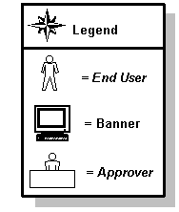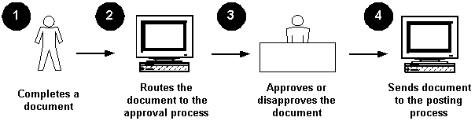
About the process
- The process is set to work globally for all Charts of Accounts when it is turned on.
- The process allows for specific documents to be approved; not all types of documents require approval.
- The approval process occurs after the completion of the document but before it is posted.
- Documents are routed to an approval queue based on matching the FOAPAL on the document to the queue routing criteria.
- The system does not allow for duplicate routing criteria.
How the routing criteria works
On the Approval Queue Routing Codes form (FOMAQRC), queues are routed based on three required fields - Document type (like Requisitions), rule group (REQG), and Chart of Accounts; and six optional fields – Fund, Fund Type, Organization, Account, Account Type and Program. The six optional fields may use their respective hierarchy (predecessor funds, fund types, organizations, accounts, account types and programs) to help route documents without building a queue for each individual fund, organization, account or program. In addition, the optional fields are arranged in priority so that funds are considered first before fund type, fund type before organization, organization before account, etc.
Furthermore, the document’s FOAPALs are matched to these required and optional fields on FOMAQRC and the document will always be routed to the approver on the queue with the most matches. If there is a case where the document has the same number of matches between the two different queues, then document will be routed to the queue that had a higher priority match.
For example, I have two queue criteria’s with the same document type, rule group and chart of accounts, and queue A had a fund criterion while queue B had an organization criterion.
A document with both the fund from queue A and the organization from queue B on it’s accounting line would be routed to queue A. The reason, both queue A and B had one match but the approval process determines that fund matches have a higher priority than organization matches.
Types of Approvals
Bypass Approvals
The approval process will be bypassed for this document type. This means the approval process is “turned off” for this document type.

Explicit Approvals
This means the approval process is “turned on” for this document type. If the originator of the document is also an approver, he/she will have to approve the document in a separate step.

Implicit Approvals
This means the approval process is “turned on” for this document type. If the originator of the document is also an approver, his/her approval will be assumed (implied) when the document is completed. No additional approval by this user will be required.

Set Up
Section goal
The purpose of this section is to outline the set-up process and detail the procedures to set-up your Banner Finance system to handle approvals.
Objectives
In this section you will learn how to
- identify and describe the maintenance forms that will be needed for the approvals process
- initiate the approvals process
- establish document approval queues
- create queue routing criteria.

Initiating the Approvals Process
Introduction
The Finance System Control Form (FOASYSC) is used to “turn on” the approvals feature.
Warning: FOASYSC is a system-wide form. Consequently, only one person can make changes to this form at one time. Only one training participant should make the changes to this form. Once any changes are made on this form, users will need to log out and log back on to Banner for the changes to take effect.
Banner form
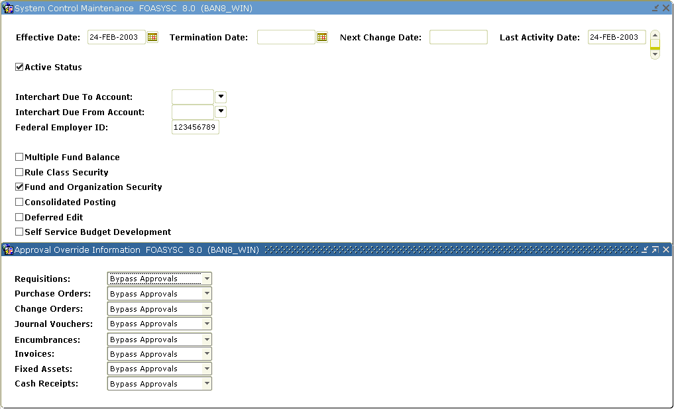

Steps
This exercise demonstrates how to establish an approval process. First you must identify the Finance documents that need to go through an approval process, and whether they need explicit or implicit approval. For this exercise, the instructor will select documents to Explicit Approvals.

- Access the System Control Maintenance Form (FOASYSC).
Warning: FOASYSC is a maintenance form. You can only make changes to it effective as of the current date. Before making any changes, you must insert a new record (F6) and duplicate the existing record (F4). Then you must change the Effective Date field to the current date.
- Perform an Insert Record function.
- Perform a Duplicate Record function.
- Change the effective date to today’s date.
- Click Approval Processing Info from the Options menu to initiate approvals processing.
Result: This will display the Approval Override Information window.
Note: In the Approval Override Information window Banner displays a list of documents for which you can establish an approval process.
- Select Explicit Approvals for the Requisitions fields.
- Verify that Bypass Approvals are selected for the remaining fields.
- Click the Save icon.
- Click the Exit icon.
- Log off the Banner system and then log on again.
Note: One must be signed off for the changes to become effective.

Establishing Document Approval Queues
Introduction
Document approval queues must be established by using the Approval Queue Maintenance Form (FTMAPPQ). In this form you specify whose approval is required for this queue, and what amounts they are authorized to approve. You can specify what types of documents and which components of the FOAPAL are to be routed to a particular queue using the Approval Queue Routing Codes Form (FOMAQRC).
Banner form
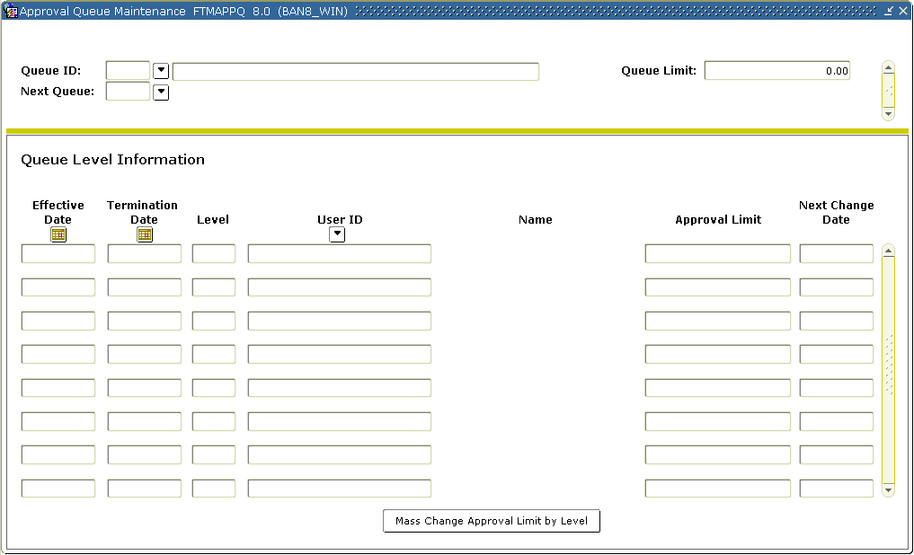
Critical fields – Key block
The critical Key block fields are

- The Queue ID can be up to four characters long. It can be alphabetic or numeric or a combination.
- The Queue Description is the name of this queue.
- The Queue Limit is the maximum amount that the highest-level approver on this queue is authorized to approve.
- The Next Queue specifies a subsequent queue (if applicable) to which you wish to route a document after this queue.

Note: A document is assigned to all queue ID’s and levels needed to approve the document at the same time. A document will be assigned to the Next Queue listed only when the document exceeds the Queue Limit of the initial queue. Queue Limits of zero are permitted; a Queue with a Queue Limit of zero can never finalize a document to forward it to posting and therefore would need to go to Next Queue.
The queue itself contains the User IDs of the personnel whose approval is required for this document, and the level of that approval. The approvers need to be set up in User Profile Maintenance form (FOMPROF).The Level setting assigned in FTMAPPQ ranks the users in that queue. A higher-level setting can “pre-empt” a lower level. If a document is approved by the level 5 user, it does not need the approval of the level 1 user (and it will only need the approval of the level 10 user if it exceeds the level 5 user’s dollar limit). Users in separate queues (for example, users in REQ1 and users in REQ2) cannot preempt one another in this way.
Note: It is recommended that, for every level of approval responsibility, you assign at least two persons. This is to avoid situations in which documents are held up because an approver is unavailable.
Other fields
The table shows fields you should know when completing the procedure that follows.

Field | Description
Effective Date | The date the approval level takes effect.
Termination Date | Used to terminate a particular approver’s approval responsibility. In most cases terminating one approver will mean inserting a new one to take over the approval responsibility.

Levels and limits for Procedure 1
Use the information in the table to complete the procedure that follows for requisitions queue

Level | Limit
1 | 1000.00
5 | 3000.00
9 | 5000.00
13 | 7500.00
17 | 10000.00
Steps - Procedure 1 – Requisitions Queue 1
This exercise will demonstrate how to establish document approval queues and the levels within the queue. Follow these steps to complete the process.
Warning: This exercise only creates two queues, so it cannot be performed by each participant. If each participant is to create a unique queue, each must have a unique ID and differing funds and organization codes.

- Access the Approval Queue Maintenance Form (FTMAPPQ).
- Create a four-character code to identify the approval queue. Enter REQ1 in the Queue ID field.
- Enter Requisitions Queue 1 in the Description field.
- Enter 10000.00 in the Queue Limit field or REQ1.
- For now, leave the Next Queue field blank.
- Enter your starting Chart date in the Effective Date field.
- Leave the Termination Date field blank.
- Enter a 1 in the Level field.
- Enter a valid User ID in the User ID field, or double-click to select one.
- Enter the dollar limit for this user’s approval in the Limit field. Use the value 1000.00.
Note: The Limit listed here can be less than the Queue Limit specified in the Key Block, but never more. This Limit applies to the listed user ID. You can list several users with graduated Limits up to the amount specified in the overall Queue Limit.
- Repeat steps 6-10 to add an additional user approval levels making sure to modify Levels and Limits for REQ 1 as listed in the table above.
- Click the Save icon.
- Perform a Rollback function.
Steps - Procedure 2 – requisitions queue 2
Follow these steps to complete the process.

- Access the Approval Queue Maintenance Form (FTMAPPQ).
- Create a four-character code to identify the approval queue. Enter REQ2 in the Queue ID field.
- Enter Requisitions Queue 2 in the Description field.
- Enter 999999999.99 in the Queue Limit field of REQ2.
- Leave the Next Queue field blank.
- Enter your starting Chart date in the Effective Date field.
Note: The Effective Date is the date the approval level takes effect.
- Leave the Termination Date field blank.
- Tab to the Level field and enter a 1.
- Tab to the User ID field and enter a valid User ID or double click in the field and select one.
- Tab to the Limit field and enter 15000.00 for the dollar limit of this user’s approval.
Note: The Limit listed here can be less than the Queue Limit specified in the Key Block, but never more. This Limit field applies to the listed user ID. You can list several users with graduated Limits up to the amount specified in the overall Queue Limit.
- Enter your starting Chart date in the Effective Date field to add an additional user approval level.
- Leave the Termination Date field blank.
- Tab to the Level field and enter a 5.
- Tab to the User ID field and enter a valid User ID or double click in the field and select one.
Note: Make sure the User ID is different than the one selected in step 10.
- Tab to the Limit field and enter 999999999.99 for the dollar limit of this user’s approval.
- Click the Save icon.
- Click the Exit icon.
Steps - Procedure 3 – NSF queue
This exercise will set up an NSF queue with a back up approver. Follow these steps to complete the process.
Note: The NSF queue will never need routing criteria since the system is built to route unsatisfied NSF conditions to this queue after the document has been approved through other approval queues. Documents will only route to the NSF queue if the approver does NOT override an NSF condition. The NSF queue is a system required queue.

- Access the Approval Queue Maintenance Form (FTMAPPQ).
- Perform an Enter Query function.
- Enter NSF in the Queue ID field.
- Perform an Execute Query function.
- If no record is retrieved, cancel your query.
- Enter NSF in the Queue ID field.
- Enter Over Budget Documents in the Description field.
- Enter 999999999.99 in the Queue Limit field of NSF.
- Leave the Next Queue field blank.
- Enter your starting Chart date in the Effective Date field.
Note: The Effective Date is the date the approval level takes effect.
- Leave the Termination Date field blank.
- Tab to the Level field and enter a 1.
- Tab to the User ID field and enter a valid User ID or double click in the field and select one.
Note: The USER ID assigned must have NSF override check in their FOMPROF.
- Tab to the Limit field and enter 0.00 for the dollar limit of this user’s approval.
- Repeat steps 10 - 14 to add an additional user approval level.
- Perform a Next Record function to add an additional user approval level
- Enter your starting Chart date in the Eff Date field.
- Leave the Term Date field blank.
- Tab to the Level field and enter a 2.
- Tab to the User ID field and enter in the same user used on step 14.
Note: this person is the main approver
- Tab to the Limit field and enter 999999999.99 for the dollar limit of this user’s approval
Note: By doing steps 11-21 we have forced approval process to send the next approver message to this user defined one levels 1 and 2. The Back-up person (steps 21-27) will not get this message - a benefit if they are filling in once and awhile.
- Perform a Next Record function to add an additional user approval level
- Enter your starting Chart date in the Eff Date field.
- Leave the Term Date field blank.
- Tab to the Level field and enter a 2.
- Tab to the User ID field and enter a valid User ID or double click in the field and select one.
Note: The USER ID assigned must have NSF override check in their FOMPROF. This is the back-up to the user on level 1
- Tab to the Limit field and enter 999999999.99 for the dollar limit of this user’s approval
- Click the Save icon.
- Click the Exit icon.

Creating Queue Routing Criteria
Introduction
Use the Approval Queue Routing Codes Form (FOMAQRC) to route documents to a particular queue. You can route documents by Document type, rule group, and FOAPAL.
Notes: Not every queue must have routing criteria. Documents will be routed to a queue that is listed as a Next Queue, even if that next queue has no routing criteria of its own.
No two queues may have identical routing criteria.
Since all documents of a given type will be routed for approval, it is important to build a “catch all queue” for each document type. Each queue would have the document type, rule group and chart of accounts as its criteria.
Banner form
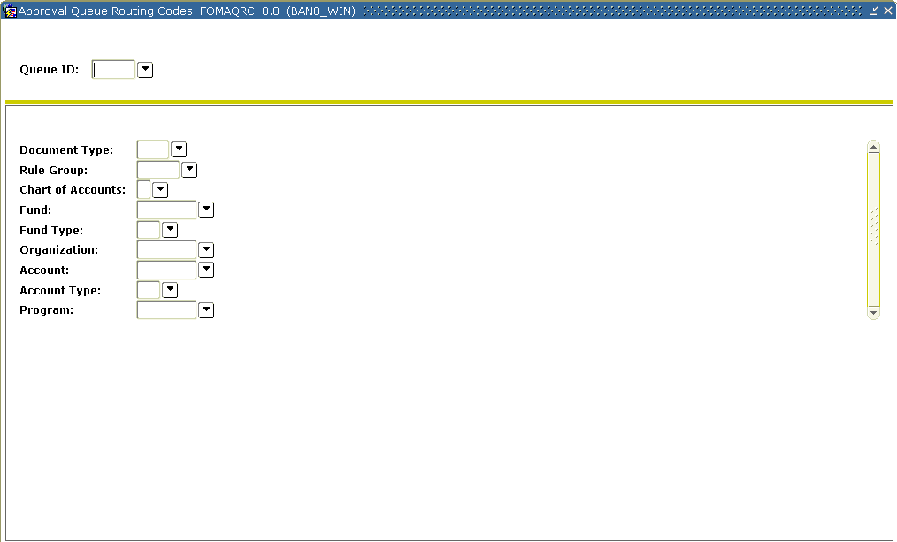

Fields
Use the information in the table to complete the procedure that follows.

Field | Description
Fund | Identifies the document’s fund code that you want routed for the queue.
Fund Type | Identifies the document’s fund type that you want routed for the queue.
Organization | Identifies the document’s organization code that you want routed to the queue.
Account | Identifies the document’s account code that you want routed for the queue.
Account Type | Identifies the document’s organization code that you want routed for the queue.
Program | Identifies the document’s program code that you want routed for the queue.
Steps
This exercise will set routing criteria for requisitions. Follow these steps to establish a document routing for new queues.
- Access the Approval Queue Routing Codes Form (FOMAQRC).
- Enter REQ1 in the Queue ID field.
- Perform a Next Block function.
- Enter REQ in the Document Type field or double-click in the field to select REQ from the list.
- Enter REQG in the Rule Group field or double-click in the field to select REQG from the list.
Note: This will identify the rule groups that Banner will route to the queue. REQG is the rule group for requisitions.
- Enter B in the Chart of Accounts field.
- Enter 1110 in the Fund field. This will identify the document’s Fund code that you want routed for the queue.
Note: Leave the Fund Type, Organization, Account, Account Type, and Program blank. See the table above for descriptions.
Note: The Document Type, Rule Group, and Chart of Account fields are mandatory. Also, you cannot enter both Fund type and Fund, or both Account type and Account.
- Click the Save icon.
- Click the Rollback icon.
- Enter REQ2 in the Queue ID field.
- Enter REQ in the Document Type field.
Result: Requisition will display next field.
- Enter REQG in the Rule Group field or double click in the field to select REQG from a list.
- Enter B in the Chart of Accounts field or double click in the field to select B from a list.
- Enter 1110 in the Fund field.
Result: This will identify the document’s Fund code that you want routed for the queue. The name of the Fund will display next to the field.
- Enter 11001 in the Organization field.
Result: This will identify the document’s Organization code that you want routed for the queue. The name of the organization will display next to the field.
- Click the Save icon.
- Click the Exit icon.

Self Check
Directions
Use the information you have learned in this workbook to complete this self check activity.
Question 1
What form lists the documents for which you can establish an approval process?
Question 2
What are the three types of approvals?
Question 3
First you must identify the Finance documents types that need to go through an approval process.
True or False?
Question 4
What is the purpose of the Next Queue field on FTMAPPQ?
Question 5
In FTMAPPQ, how can one determine if a change was made to the approval queues?

Question 6
In FTMAPPQ, if you wanted to create a queue and ensure that every document that went through this queue proceeded to the Next Queue, what value would you assign as the Queue Limit?

Answer Key for Self Check
Question 1
What form lists the documents for which you can establish an approval process?
The System Control Maintenance Form (FOASYSC)
Question 2
What are the three types of approvals?
Bypass Approvals
Explicit Approvals
Implicit Approvals
Question 3
First you must identify the Finance documents types that need to go through an approval process.
True
Question 4
What is the purpose of the Next Queue field on FTMAPPQ?
The Next Queue field will identify the next “queue” that must also approve the same type of documents. A document is assigned to all queue ID’s and levels needed to approve the document at the same time. A document will be assigned to the Next Queue listed only when the document exceeds the Queue Limit of the initial.
Question 5
In FTMAPPQ, how can one determine if a change was made to the approval queues?
The Next change Date field will display the date the last changed occurred to an approval level.
Question 6
In FTMAPPQ, if you wanted to create a queue and ensure that every document that went through this queue proceeded to the Next Queue, what value would you assign as the Queue Limit?
Zero. A queue with a zero limit would require a Next Queue (since it couldn’t approve any documents itself) but all documents could be required to go through this queue before proceeding.

Day-to-Day Operations
Section goal
The purpose of this section is to explain the day-to-day or operational procedures to handle finance approvals procedures at your institution.
Objectives
In this section you will learn how to
- create requisitions for approval and run the approvals process
- route documents to specific users based upon the approval queues
- determine if documents are awaiting your approval and approve them if necessary
- work with NSF checking and approvals
- display approval history for a document.

Process Introduction
About the process
The day-to-day process involves creating a document that goes through the approval process.
Flow diagram
This diagram highlights the processes used to process finance approvals.

What happens
The stages of the process are described in this table.

Stage | Who/what does it | Description
1 | End user | completes a document (voucher, requisition, etc.).
2 | Banner | routes the document to the approvals process.
3 | Approver | approves or disapproves the document.  Note: Based on the document and approval queues, the document is routed appropriately. The disapproved document is ‘opened up’ again and sent back to the original person who created it to either adjust or delete it. If adjusted, the document will go through the approval process once again.
4 | Banner | sends the approved document to the posting process.

Creating Requisitions for Approval
Introduction
The Requisition Form (FPAREQN) is used to create and maintain the header, commodity, and accounting information for requisitions. Since, in an earlier procedure, we turned on approvals for requisitions, all requisitions will now be routed for approval when the processor clicks on the completion button.
Note: Documents for which approvals are required do not post until all required approvals have been obtained.
Note: If a requisition includes FOAPAL elements that are routed to two different queues, the requisition will require the approvals listed on both of these queues.
Banner form
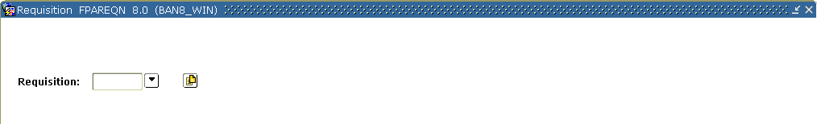
Steps
Each person should enter at least three requisitions. The first one should be an amount below your approval queue amount in queue, REQ1. The second should be below your approval queue amount in queue, REQ2. The third one can have any amount, but should have a fund other than 1110 and an organization other than 11101.
Follow these steps to complete the process.

- Access the Requisition Form (FPAREQN).
- Enter Next in the Requisition field.
- Perform a Next Block function.
- Change the order date in the Order Date field if the current date is not accurate.
- Change the transaction date in the Transaction Date field if the current date is not accurate.

- Enter a delivery date in the Delivery Date field.
Note: The delivery date must be the same as or later than the order date.
- Enter the requestor in the Requestor field.
Note: If set up, the value will default based on FOMPROF settings.
- Enter B in the COA field.
- Enter 11001 in the Organization field.
- Click the Search icon, and enter a shipping address in the Ship To field.
Note: When you select a shipping address the Address, Phone, Contact, and Attention fields will be filled in. If set up, the value will default based on FOMPROF settings.
- Select the Vendor Information tab.
- Select a vendor in the Vendor field.
Note: Once a vendor is selected, the remaining fields will be filled in for you, if the Procurement address exists for the vendor.
If you need to create a vendor or add address information for the vendor, use the Vendor Maintenance Form (FTMVEND).
- Select the Commodity/Accounting tab.
- Select a commodity in the Commodity field.
- Select a unit of measure in the U/M field. In this exercise select EA.
- Tab to the Quantity field and enter 1 for the quantity of items to be requested.
- Tab to the Unit Price field and enter $950 for the unit price of this commodity.
- Tab to the Commodity field.
- Perform a Next Block function.
- Enter B in the COA field.
- Fiscal year will default in based on the transaction date.
- Enter 1110 in the Fund field.
- Enter 11005 in the Orgn field.
- Enter 7210 in the Acct field.
- Enter10 in the Prog field.
- Go to the USD extended field.
- Enter 950.
- Select the Balancing/Completion tab.
- Review the Header, Commodity, and Accounting amounts.
- If these amounts are in balance, click the Complete button.
- Note the message in the lower left-hand corner of your screen. This message should note that your Requisition has been “forwarded to the Approval Process.”
Note: Make a note of this and the following Requisition numbers. You want to track the progress of this document through the Approvals process.
- Click the Rollback icon.
- Repeat Steps 2-30 to create another requisition, but change the organization to 11001 and make the amount of the requisition $16,000.
- Click the Rollback icon.
- Repeat Steps 2-30 to create your third and final requisition, but sure the fund code in FOAP is not fund 1110 nor the organization code is 11001.
- Click the Exit icon.

Running the Approvals Process
Introduction
The Approvals Process (FORAPPL) is the process that reviews completed documents and ‘maps’ their approval requirements, i.e., assigns them to the queues you created in the preceding Lessons. This process collects all documents in the FOBAPPD table and searches for queues appropriate to them. The output for this process lists all documents it has encountered, including errors encountered, e.g., documents for which no appropriate approval queue could be found.
Normally, the FORAPPL process will be set up to run in “sleep/wake” mode in your production environment. That is, it will run in background, checking at regular intervals (between 30 and 120 seconds recommended) for any recently completed documents, and assigning their approvals without any manual intervention. However, you need to be aware of this process and how it runs. In this exercise you will run the Approval Process manually, and review the results of it.
Note: It is important to regularly review the output of the FORAPPL process, even when it is set up to run in “sleep/wake” mode. This output will alert you to documents that are not finding appropriate approval queues (e.g., document exceeds queue limit, FOAPAL not on any queue).
Banner form
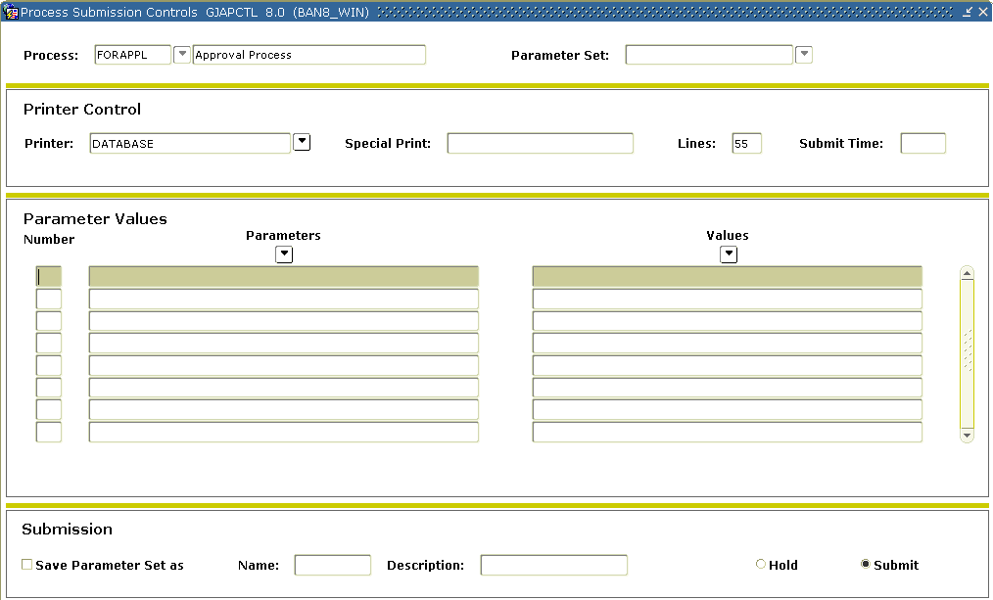
Steps
In this exercise you’ll submit the FORAPPL process through the Job Submission Control Form (GJAPCTL) and review the output. Follow these steps to complete the process.

- Access the Approvals Process (FORAPPL).
- Enter DATABASE in the Printer field (or select a valid printer from the List of Values associated with this field).
- Perform a Next Block function.
- Note that there are no Parameters for this process.
- Perform a Next Block function.
- Click the Save icon.

Determining If Documents are Awaiting Your Approval
Introduction
To ensure that documents are not held up in the Approvals Process, it is important that all approvers understand the necessity of reviewing documents awaiting approval in a regular and timely manner. There are two major forms provided for the review of documents awaiting approval. One of these, the Approvals Notification Form (FOIAINP) is a prompting form. When you first log onto Banner it will display automatically when you access any other Banner Finance form if you are an approver and if there are unapproved documents awaiting your approval. FOIAINP will list the types and number of documents awaiting your approval. You may use the User Approval Form (FOAUAPP) to access the documents awaiting your approval.
Banner forms
The User Approval Form (FOAUAPP) is the form used for the actual approval of documents (as will be discussed later), but it is also the most versatile and useful form for querying the status of unapproved documents.
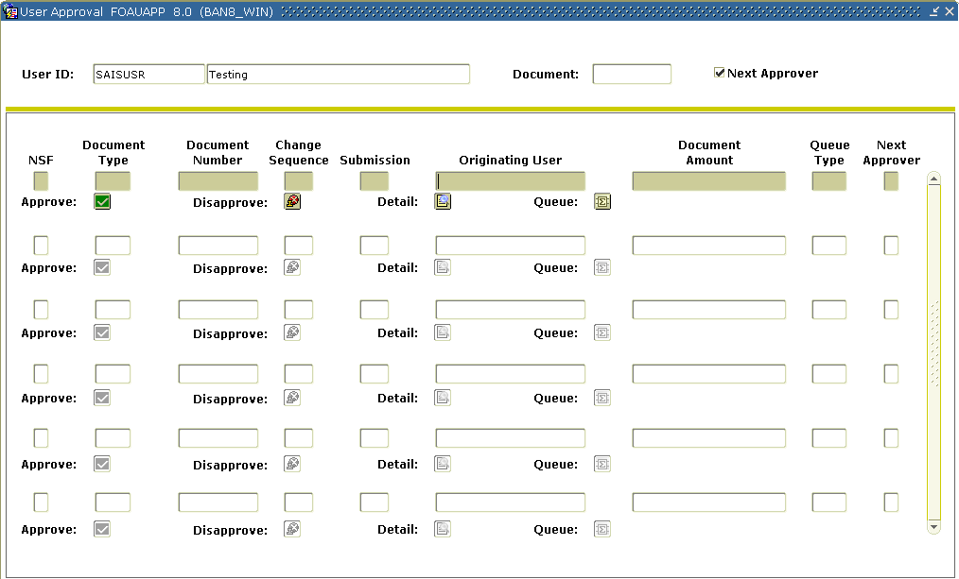

Steps
Follow these steps to complete the process.

- Access the Approvals Notification Form (FOIAINP).
- Click User Approval from the Options menu to access the User Approval Form (FOAUAPP).
Note: The User ID field defaults with the ID that you used to log into the system.
- Perform a Next Block function.
- If your User ID is not listed on one of the Approval Queues created, then no documents will be displayed.
- Click the Rollback icon.
- Delete your ID from the User ID field.
- Perform a Next Block function.
Note: You will now see ALL of the documents that are currently awaiting approval.
- Choose a document and click on the Queue button to determine whose approval a particular document is awaiting,
Note: You will access the Document Approval Form (FOAAINP).
- Perform a Next Block function.
Result: The required approvals for this document will be displayed.
- Click the Exit icon.
Note: You’ll be returned to the User Approval Form (FOAUAPP).
- Perform an Enter Query function.
- In the Originating User field, enter your user ID.
- Perform an Execute Query function.
Note: The three requisitions you created should be listed.
- Click the Exit icon.
Disapproving Your Own Document Still in an Approval Queue
Introduction
The Document by User (FOADOCU) form can be used to disapprove your own documents when they are in an approval queue.
Banner form
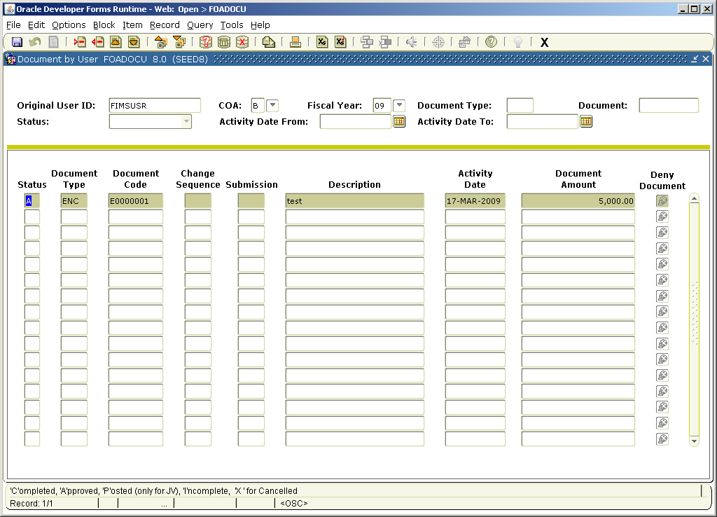
Steps
- Access Document by User Form (FOADOCU).
Note: Notice that your ID will default into the User ID field.
- Perform a Next Block function.
- Use the vertical scroll bar to scroll to find the document that you want to disapprove.
- Click the Deny Document icon to disapprove your own document.
- Click the Exit icon
Approving a Document
Introduction
The User Approval Form (FOAUAPP) enables you to approve or disapprove a document, view a document’s detail, and view all the queues/levels responsible for approving the document.
Banner form

Note: The Originator displayed in FOAUAPP will be the user who last completed the document.

Steps
This procedure will display the explicit approval process that takes place when a document is approved.
Note: If you can approve the document’s total dollar amount, after you approve it, Banner removes it from the approval queue and moves it to its next processing stage.

- Access the User Approval Form (FOAUAPP).
Note: Notice that your ID will default into the User ID field. With no ID in the User ID field, this form displays all unapproved documents. Even if you are not an approver, you can perform any of the functions provided by this form except for Approval or Disapproval.
- Perform a Next Block function.
Note: Documents will display only if your approval is required (if your ID was entered as an approver for the REQ1 or REQ2 queues in FTMAPPQ). If not, then nothing will display.
- Use the vertical scroll bar to scroll through the list of documents that need to be approved.
- If you are an approver, click the Details icon.
Result: Accounting information regarding this document is presented.
- If you are an approver, find a requisition and approve it by clicking the Approval icon.
Result: A pop up window will appear with the message stating that the document is approved.
- Click the OK button.
Result: The document has been approved and the FORAPPL process needs to be run before the document will go to posting process if the dollar amount of the req was under this approvers limit.

- If you are an approver, find a requisition and disapprove it by clicking the Disapprove icon.
Result: A pop up window will appear with the message stating that the document is disapproved.
- Type an explanatory message in addition to the original message as to why the document was disapproved.
Note: This message will be forwarded to the originator of the document using the Banner mail function, and to any previous approvers of the document.
- Click the OK button.
Result: Note the document has been disapproved and the FORAPPL process needs to be run before the document is available for correction by the originator.
- Click the Exit icon.

Working with NSF Checking and Approvals
Introduction
The NSF checking feature of Banner performs differently when you implement the Approvals process. Remember that there are three key places where you control how you want Banner to perform its NSF review of your documents.
- In the System Control Form (FOASYSC) you can specify, by document type, that you want the system to review budget balances for each document processed.
- In the Chart of Accounts Maintenance Form (FTMCOAS), you designate whether NSF conditions are to be treated with a simple warning alone (W), or will generate an error that requires manual override (E).
- In the User Profile Form (FOMPROF) you give each user authority (or not) to override NSF conditions.

If your NSF setting is for warning alone, then a document that exceeds budget will generate a warning message, but, whether you are running the approvals process or not, there are no further processing consequences (for example, the document can be completed and posted and will take its budget line into the red).
On the other hand, if your NSF setting is for an error there is a difference between what will happen with Approvals off versus with Approvals on. In the first case, the user will not be able to complete the document unless they have NSF override authority in FOMPROF. In the latter case, any user can complete an NSF document, since it will be forwarded to the Approvals process. The NSF condition must be overridden, however, by any one of its approvers (someone who has NSF override authority in FOMPROF). If it is not, the document will be forwarded after all other approvals have been obtained, to the “NSF” queue.
Note: You must assign personnel to the “NSF” queue. Use the FTMAPPQ form and the Queue ID “NSF.” No routing is necessary for this queue. Documents will only end up in this queue if no one overrides the NSF condition during the normal approvals process.

Banner form
Chart of Accounts Maintenance Form (FTMCOAS)
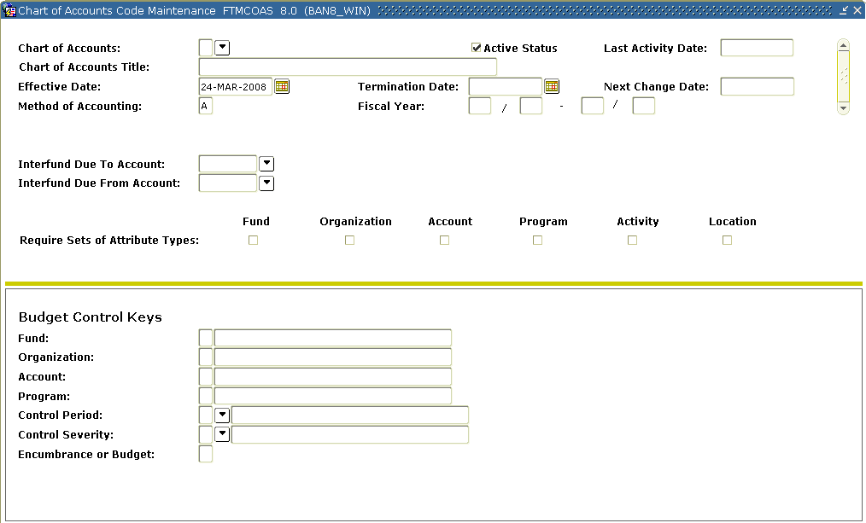
Steps
In this exercise, you will set your NSF checking in FTMCOAS to ‘E’rror. Follow these steps to complete the process.

- Access the Chart of Accounts Maintenance Form (FTMCOAS).
- Perform an Enter Query function.
- Enter B in the Chart of Accounts Code field.
- Perform an Execute Query function.
- Perform an Insert Record function.
- Perform a Duplicate Record function.
- Enter the current date in the Effective field.
- Tab to the Control Severity field.
- If the setting is currently W, enter E (if it is already E, leave it as is).
- Click the Save icon.
- Click the Exit icon.
Discussion
In order to examine NSF Checking with Approvals, it is necessary to generate some requisitions with an NSF condition. Use the Requisition Form (FPAREQN) to create requisitions. The requisition will generate an NSF error if the FOAPAL used is one that has no budget (or less than the amount of the requisition) in the “Available Budget” column of the Budget Query Form (FGIBDST).
Note: NSF checking is particularly important in Banner, because, in addition to checking for exceeded budgets, the NSF checking warns of invalid FOAPAL combinations.
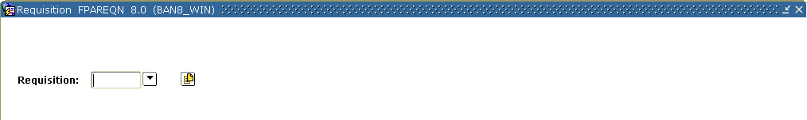
Steps
Each person should enter at least two requisitions. As before, the fund and organization should correspond to those on our approval queues.

- Access the Requisition Form (FPAREQN).
- Enter Next in the Requisition field.
- Perform a Next Block function.
- Change the order date in the Order Date field if the current date is not accurate.
- Change the transaction date in the Transaction Date field if the current date is not accurate.
- Enter a delivery date in the Delivery Date field.
Note: It must be equal to or greater than the order date.
- Enter the requestor in the Requestor field.
Note: If set up, your FOMPROF settings will default.
- Enter B in the COA field.
- Enter 11001 in the Organization field.
- Click the Search icon, and enter a shipping address in the Ship To field.
Note: When you select a shipping address the Address, Phone, Contact, and Attention fields will be filled in. If set up, the values will default from FOMPROF.
- Select the Vendor Information tab.
- Select a vendor in the Vendor field.
Note: Once a vendor is selected, the remaining fields will be filled in for you, if the Procurement address exists for the vendor. If you need to create a vendor or add address information for the vendor, use the Vendor Maintenance Form (FTMVEND).
- Select the Commodity/Accounting tab.
- Enter a commodity in the Commodity field.
- Select a unit of measure in the U/M field. In this exercise select EA.
- Tab to the Quantity field and enter in 1 for the quantity of items to be requested.
- Tab to the Unit Price field and enter in $950 for the unit price of this commodity.
- Tab to the Commodity field.
- Perform a Next Block function.
- Enter B in the COA field.
- Note: Fiscal year will default in based on the transaction date.
- Enter 1110 in the Fund field.
- Enter 11001 in the Orgn field.
- Enter 7210 in the Acct field.
- Enter 10 in the Prog field.
- Go to the USD extended field.
- Enter 950.
- Select the Balancing/Completion tab.
Note: You should receive a message telling you that the ‘Budget is Exceeded.’
- Review the Header, Commodity, and Accounting amounts.
- If these amounts are in balance, click the Complete button.
- Note the message in the lower left-hand corner of your screen. This message should note that your requisition has been “forwarded to the Approval Process.”
Note: Make a note of this and the following requisition numbers. You want to track the progress of this document through the Approvals process.
- Click the Rollback icon.
- Repeat Steps 2-30 to create another requisition, but change the organization to 11001 and make the amount of the requisition $16,000.
- Click the Exit icon.
Viewing and Overriding NSF Documents
Introduction
In the last procedure, you created requisition records that generated an NSF error. In order to see how the Approvals process handles these requisitions, you must first rerun this process (FORAPPL). Then you can use the User Approval Form (FOAUAPP) to review these documents and override their NSF conditions. In FOAUAPP, NSF documents are approved in two steps.

- First you must override the NSF condition, using the Detail button.
- Secondly, you must approve the document, using the Approval button.

As mentioned previously, if the NSF condition is not overridden, the document will be forwarded to the “NSF” queue. When a document has been forwarded to the “NSF” queue it must be approved by someone listed as an approver for that queue, in FTMAPPQ. The document will be approved in the manner described above, with an override of the NSF condition and then with approval.
Note: The Next Approver switch at the top of the FOAUAPP form permits an approver to limit the displayed documents to those for which he/she is the next needed approver. This permits a “high-level” approver to ignore documents until they’ve received all necessary lower-level approvals.

Banner form
User Approval Form (FOAUAPP)
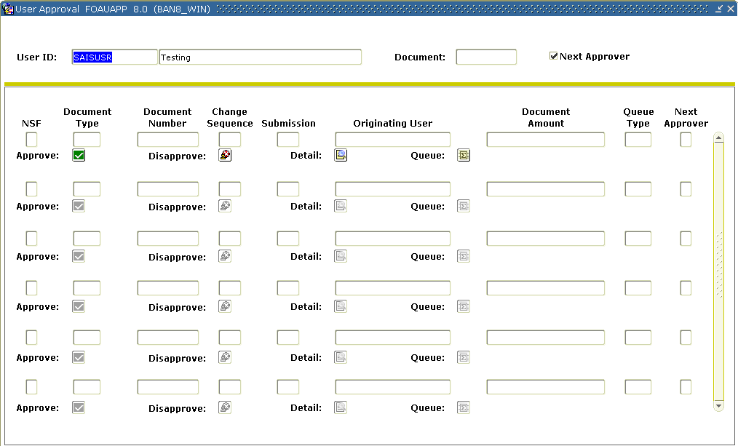
Steps
In this exercise you will override the NSF condition for one of your Requisitions in FOAUAPP. You will Approve the other document, but without overriding the NSF error. This document will be forwarded to the NSF queue. Follow these steps to complete the process.

- Run the Approvals Process (FORAPPL). Ensure that the requisitions you entered previously have been assigned to approval queues.
- Access the User Approval Form (FOAUAPP).
- If you are an approver, enter your user ID in the User ID field. (Otherwise, leave this field blank).
Note: A Y (Yes) displays in the NSF field if this document is over budget. A Y (Yes) displays in the Next Approver field if you are the next person to approve the document.
- Perform a Next Block function.

- Find one of the requisitions you entered previously. Is the NSF field showing a Y?
- Click the Detail button.
- Click the NSF Override checkbox so that a check mark appears.
- Click the Save icon.
Result: The NSF box should change from Y to N.
Warning: You will not be allowed to make this change unless you have NSF override authority on your User Profile in FOMPROF.
- Click the Exit icon.
Result: You will return to FOAUAPP.
- Click the Approval button.
- Make sure that any other user who is required to approve this document also approves it (only one user needs to perform the NSF override).
Result: You have overridden the NSF condition and approved this document.
- Move to the other requisition you entered previously. Is this one also showing a Y in the NSF field?
- Click on the Approval button.
- Make sure that any other user who is required to approve this document also approves it (don’t have anyone perform an NSF override, however).
- Click the Exit icon to exit the FOAUAPP form.
- Rerun the Approvals Process (FORAPPL) as you did in Step 1.
- Return to the User Approval Form (FOAUAPP).
- If you are an approver, enter your user ID in the User ID field. (Otherwise, leave this field blank).
Note: A Y (Yes) displays in the NSF field if this document is over budget. A Y (Yes) displays in the Next Approver field if you are the next person to approve the document.

- Perform a Next Block function.
Result: Notice that the first of your requisitions is no longer awaiting approval. The second, however, will still display, although ALL of its approvers have approved it.
- Review the document using the Queue button.
Result: Your second document is now in the “NSF” queue.
- Have someone with the authority override the NSF for this second document and approve it.
Note: It must now be approved by someone assigned to the NSF queue in FTMAPPQ.
- Rerun the Approvals Process (FORAPPL).
- Return to the User Approval Form (FOAUAPP).
- Verify the second document is updated and clears from the approvals.

Displaying the Approval History for a Specific Document
Introduction
There are two forms that can be used to display the approval history for a specified document, Document Approval History Form (FOIAPPH) and Approval History Form (FOIAPHT). The Document Approval History Form (FOIAPPH) displays the approval history for a specified document. This form best illustrates implicit approval tracking for a document. The Approval History Form (FOIAPHT) provides an online display of documents sorted by Document Code. A document that has been denied appears with a queue ID of DENY.
Banner forms
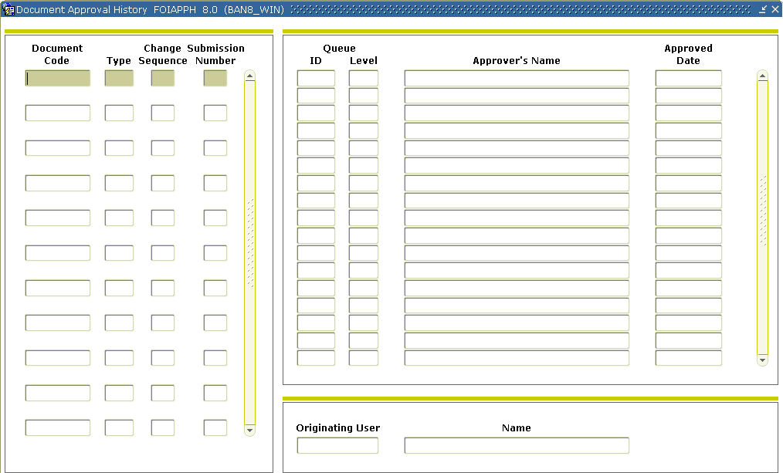
Steps – Procedure 1
This procedure will demonstrate how to view the approval history of a document.

- Access the Document Approval History Form (FOIAPPH).
- Go to the left of the form.
Note: The area to the left displays documents in sequential order within Document type.
- Select the second document.
Result: When you highlight/select a document in the area to the left, Banner displays the queues and approval levels and approvers’ names that approved each document in the area on the right.
- Click the Exit icon.

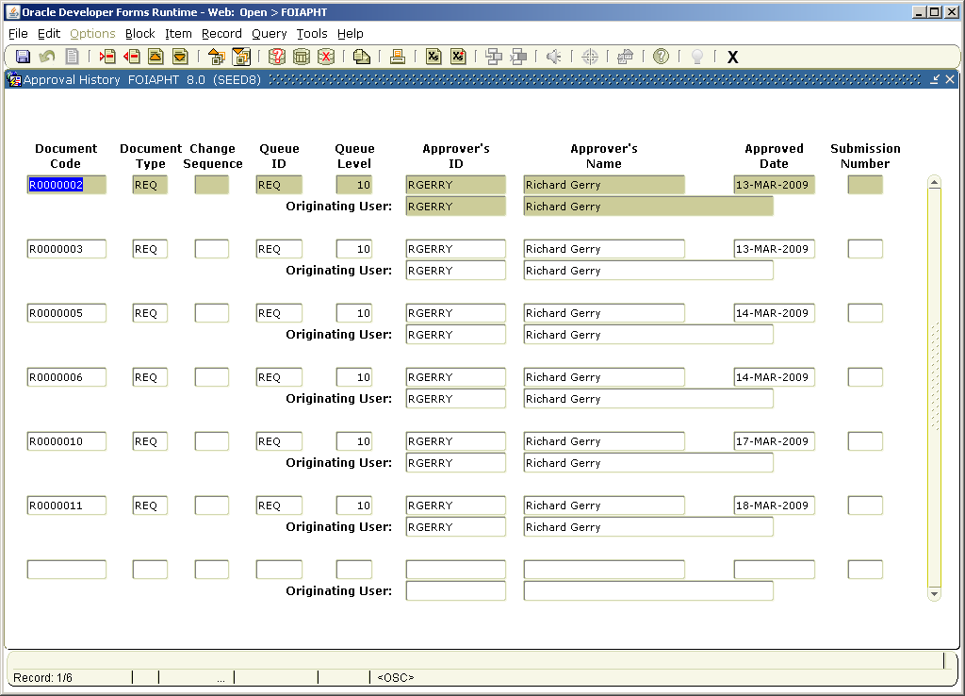
Steps – Procedure 2
This procedure will demonstrate how to use this form.

- Access the Approval History Form (FOIAPHT).
- Enter query mode.
- Tab to the field in which you want to enter query criteria and enter your criteria.
- Execute the query.
- Click the Exit icon.
Summary
Let’s review
As a result of completing this workbook, you have

- created requisitions for approval and run the approvals process
- routed documents to specific users based upon the approval queues
- determined if documents are awaiting your approval and approved them if necessary
- worked with NSF checking and approvals
- displayed approval history for a document.
Next step
This course examined only one document to be approved – requisitions. The next step would be to turn on approvals for other documents, such as Journal Vouchers, you know how to process and see how they are impacted. Also, the approval process should be tested between implicit and explicit approvals.
Self Check
Directions
Use the information you have learned in this workbook to complete this self check activity.
Question 1
List the different ways in which you can route documents.
Question 2
Both of our queues specify a fund of 1110. What will happen to a document with a different fund?
Question 3
Is it possible to require approvals for some requisitions, but not all requisitions?
Question 4
Will the Requisition with a total amount under the Queue Limit for REQ1 be routed to REQ2?
Question 5
If a Requisition has multiple FOAPAL elements and these correspond to the routing on different Approval Queues, which queue will it be assigned to?
Question 6
Name at least one reason that a document might be “rejected” (unable to be assigned to an approval queue) by the approval process.
Question 7
The Approvals Process has to be manually run for every completed document.
True or False?
Question 8
If a document is “rejected” by the Approvals Process, what can be done to fix it?
Question 9
How is a user notified by the system that he/she has a document waiting to be approved?
Question 10
When will documents display in FOAUAPP under your user ID?
Question 11
What happens to a document if an approver “disapproves” it?
Question 12
A higher-level approver within a queue CAN pre-empt a lower-level approver (that is, bypass their approval). Approvers on separate queues CANNOT pre-empt one another.
True or False?
Question 13
Will the “NSF” queue automatically be included in the approvals for any document that has an NSF status?
Question 14
Banner’s Chart of Accounts allows you to define funds, organizations, and accounts separately. How is it possible to ensure that users use these codes only in the intended combinations?
Question 15
If you completed a Requisition and now want to make changes, what can you do to retrieve the record?
Question 16
What is the purpose of the Next Approver switch in the Key Block of the FOAUAPP form?
Question 17
Identify the information that is displayed when a document is highlighted on the Document Approval History Form.

Answer Key for Self Check
Question 1
List the different ways in which you can route documents.
By Document Type, Rule Group, Chart of Accounts and FOAPAL.
Question 2
Both of our queues specify a fund of 1110. What will happen to a document with a different fund?
The FORAPPL process will be unable to find a place for it, and will produce an error.
Question 3
Is it possible to require approvals for some requisitions, but not all requisitions?
No. Once approvals are turned on for requisition, then all requisitions require approvals.
Question 4
Will the Requisition with a total amount under the Queue Limit for REQ1 be routed to REQ2?
No. A document under the Queue Limit will require no further approval.
Question 5
If a Requisition has multiple FOAPAL elements and these correspond to the routing on different Approval Queues, which queue will it be assigned to?
All of them.
Question 6
Name at least one reason that a document might be “rejected” (unable to be assigned to an approval queue) by the approval process.
The FOAPAL of the document can’t be matched to the routing on any Queue in FTMAPPQ. Also, if the document amount exceeds the Queue Limits.
Question 7
The Approvals Process has to be manually run for every completed document.
False. The Approvals Process (FORAPPL) will be set up to run in background (sleep/wake).
Question 8
If a document is “rejected” by the Approvals Process, what can be done to fix it?
The Queue can be corrected, in FTMAPPQ or FOMAQRC, and then the FORAPPL process can be rerun.
Question 9
How is a user notified by the system that he/she has a document waiting to be approved?
When you first log onto Banner the Approvals Notification Form, FOIAINP, displays automatically after you request any of the Banner Finance forms, or one may go to FOAUAPP.
Question 10
When will documents display in FOAUAPP under your user ID?
Only when your user ID is listed in FTMAPPQ as an approver, and when documents with a FOAPAL routed to your queue in FOMAQRC exist.
Question 11
What happens to a document if an approver “disapproves” it?
The document is returned to an incomplete status. A disapproval message is returned to the originator of the document and to any previous approver of the document.
Question 12
A higher-level approver within a queue CAN pre-empt a lower-level approver (that is, bypass their approval). Approvers on separate queues CANNOT pre-empt one another.
True
Question 13
Will the “NSF” queue automatically be included in the approvals for any document that has an NSF status?
No. Documents will only reach the “NSF” queue if none of the regular approvers override the NSF condition.
Question 14
Banner’s Chart of Accounts allows you to define funds, organizations and accounts separately. How is it possible to ensure that users use these codes only in the intended combinations?
NSF checking will alert you to invalid COA combinations (since these will be unbudgeted).
Question 15
If you completed a Requisition and now want to make changes, what can you do to retrieve the record?
You can request that an approver disapprove your document or go to FOADOCU and disapprove your own document. This will return the document to an incomplete status, permitting changes.
Question 16
What is the purpose of the Next Approver switch in the Key Block of the FOAUAPP form?
This switch permits a high-level approver to limit the displayed documents to those that have already received any prior necessary approvals.
Question 17
Identify the information that is displayed when a document is highlighted on the Document Approval History Form.
When a document is highlighted, Banner displays the queues and approval levels and approvers’ names that approved each document in the area on the right.

Appendix

Forms Job Aid

Form | Full Name | Use this Form to...
FOAUAPP | User Approval Form | approve a document or navigate to summary information of a document for review and subsequent approval.
FOAAINP | Document Approval Form | display all the queues/levels responsible for the approval of a specified document.
FOIAINP | Approvals Notification Form | display all documents that await your approval.
FOIAPPH | Document Approval History Form | view the approval history for a specified document.
FOIAPHT | Approval History Form | view documents sorted by Document Code. A document that has been denied appears with a queue ID of DENY.
FOMAQRC | Approval Queue Routing Codes Form | establish routing paths for documents by document type, rule group, and chart of accounts.
FTMAPPQ | Approval Queue Maintenance Form | establish document approval queues and optionally associate next queues.

Backup Approvers Set Up 1
Scenario 1
Many times a queue will only have one person in a department as the approver. Someone in the department, or if no one is appropriate in the department, someone in the finance office then needs to be set up as a backup approver for when the approver is unavailable. This scenario shows the set up for a back up approver in the simplest case where the Approver will be notified of documents for approval but the backup approver will not.
Queue Set Up

Username | Approval Limit
Approver 1 | 9,999,999,999.99
Backup Approver | 9,999,999,999.99
Queue Level | Username | Amount
10 | Approver 1 | 0.00
20 | Approver 1 | 9,999,999,999.99
20 | Backup Approver | 9,999,999,999.99

Backup Approver Set Up 2
Scenario 2
In this scenario, the first approver will approve all documents. If the value exceeds $1,000, the document will also require approval of the second approver. If the value exceeds $25,000, the document will also require approval of the third approver, who has unlimited authority to approve. The Backup approver also has unlimited authority to approve and can exercise that authority for any approver in the queue.
Queue Set Up

Username | Approval Limit
Approver 1 | 1,000.00
Approver 2 | 25,000.00
Approver 3 | 9,999,999,999.99
Backup Approver | 9,999,999,999.99
Queue Level | Username | Amount
10 | Approver 1 | 0.00
20 | Approver 1 | 1,000.00
20 | Backup Approver | 1,000.00
30 | Approver 2 | 0.00
40 | Approver 2 | 25,000.00
40 | Backup Approver | 25,000.00
50 | Approver 3 | 0.00
50 | Approver 3 | 9,999,999,999.99
50 | Backup Approver | 9,999,999,999.99
Backup Approver Set Up 3
Scenario 3
In this scenario, all approvers can give final approval for documents within their dollar amount authority. The Backup approver also has unlimited authority to approve but will not be informed of documents for approval by other approvers.

Queue Set Up

Username | Approval Limit
Approver 1 | 1,000.00
Approver 2 | 25,000.00
Approver 3 | 9,999,999,999.99
Backup Approver | 9,999,999,999.99
Queue Level | Username | Amount
10 | Approver 1 | 0.00
20 | Approver 1 | 1,000.00
20 | Approver 2 | 1,000.00
20 | Approver 3 | 1,000.00
20 | Backup Approver | 1,000.00
30 | Approver 2 | 0.00
40 | Approver 2 | 25,000.00
40 | Approver 3 | 25,000.00
40 | Backup Approver | 25,000.00
50 | Approver 3 | 0.00
50 | Approver 3 | 9,999,999,999.99
50 | Backup Approver | 9,999,999,999.99

