 | Mississippi Banner Users Group  2007 Conference  September 23 – 25, 2007

This year our MBUG Conference will be held at the Grand Casino Resort in Tunica, Mississippi www.harrahs.com. We are working to confirm presenters so the final agenda will be sent to you at a later date. We need user participation to make our conference as informative as possible. If you would like to make a presentation, please contact Bettye R. Graves, bettye.r.graves@jsums.edu, Diane Garvin, dlgarvin@iccms.edu, or Sherry Floyd, swfloyd@nemcc.edu.

General Information:

- Our guest speaker for Monday’s luncheon will be Tricia Walker, a Mississippi native with 25 years experience as singer/song writer in Nashville, Tennessee. She is currently Director of Delta Music Institute at Delta State University.

- If you plan to bring a guest, please indicate on your registration form and include a $50.00 guest fee. The guest fee entitles entry to the Sunday evening social, Monday luncheon, and Monday night social.

- Hotel room rates are $79.00/night at The Grand Casino Veranda Hotel. Reservations may be made by calling 1-800-HARRAHS (800-427-7247). To ensure availability, hotel reservations must be made by August 20, 2007. Use the following group code: S09MBUG. The following link will also be available to make online reservations:

http://www.harrahs.com/CheckGroupAvailability.do?propCode=GTU&groupCode=S09MBUG

Conference registration deadline is August 15, 2007. In the past, we have had problems getting all registration forms and fees in by the deadline date. So please be conscientious of this deadline.

Mississippi Banner Users Group
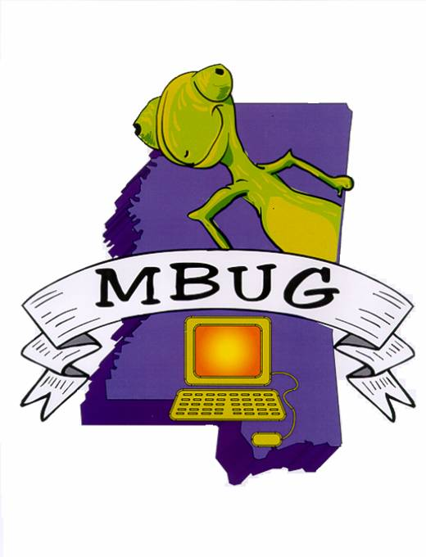
2007 Conference
Grand Casino Resort
Tunica, Mississippi

Registration/Invoice Form:

Name:
Title:
Institution:
Email Address:

Please check primary track:
Alumni
Finance
Financial Aid
Human Resources
Student
Technical

I will be bringing a guest to the Sunday reception or Monday luncheon. | Yes |  | No

Guest name (for nametag):

Conference Fees: $75.00 per Attendee
$50.00 Guest Fee
$100.00 Non-member Attendee
$100.00 On-site Registration Fee
($75.00 Conference Fee plus $25.00 Late Fee)

**Conference registration deadline is August 15, 2007. All registration received after that date will be considered late registration. On-site registration must be paid by Institution Check, Personal Check, or Money Order.

Total Amount Due: $

Make checks payable to: MS Banner Users Group, Inc
EIN: 20-0444828

Mail payment and registration form by August 15, 2007 to:

Becky Finley
Delta State University
Registrar’s Office
Kent Wyatt Hall 152
Cleveland, MS 38733
662-846-4042
becky@deltastate.edu

